

Industrial Visit

Smt. S.R. Patel Engineering College, Dabhi

Engineer at MCBS explaining theStudents

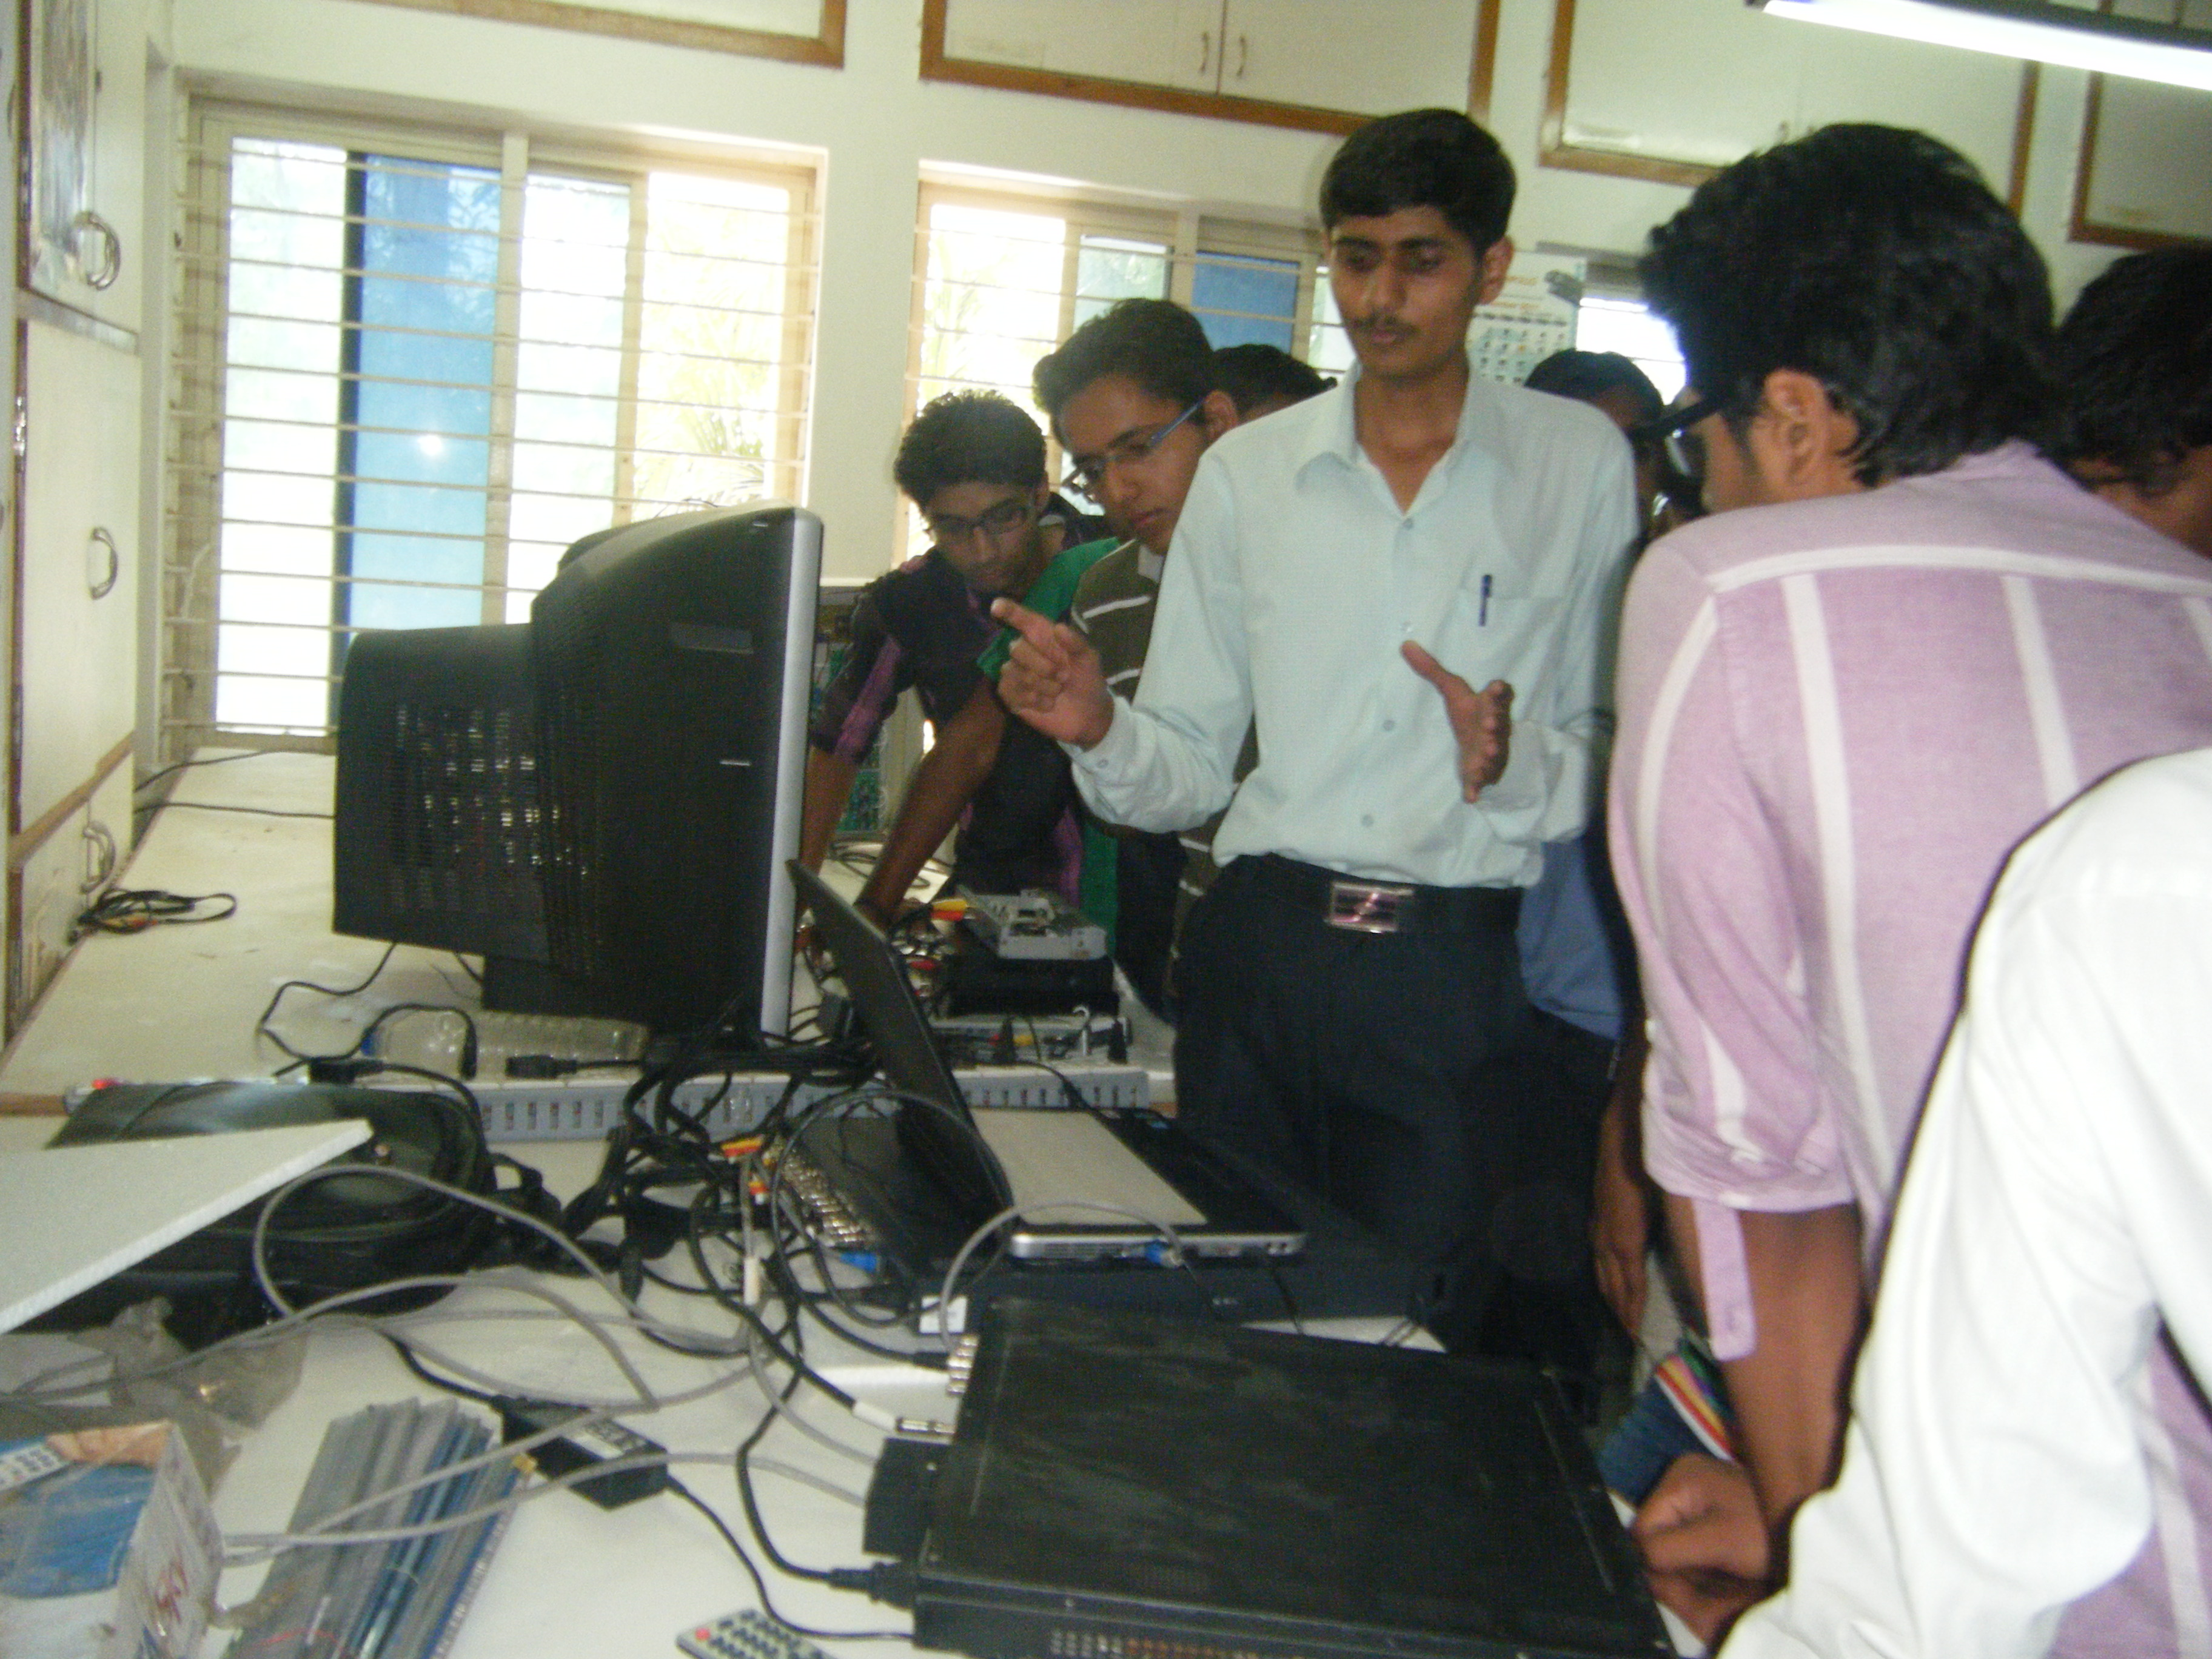

Ph. :

Fax :

Email:

Visit Date:

#### Objective of Visit:

•

## Visit to

Add Photo

Add Photo

Engineer at MCBS explaining theStudents



**Faculty in-Charge**

**Site in-Charge**

**Phone:**

**Fax:**

**Website:**

1379/ 80

**Fax:**

079-2324 1465

**Email:**

[info@sahajanandlaser.com](mailto:info@sahajanandlaser.com)

## Site Detail Contact Details

**Address:**